**AssignmentNumber:10.4**(Present assignment number)/**24**(Total number of assignments)

2403A52220

Shaik Asif

B.No-08

**Task 1: Syntax and Error Detection**

**Task:** Identify and fix syntax, indentation, and variable errors in the given script.

# buggy_code_task1.py

def add_numbers(a, b)

result = a + b

return reslt

print(add_numbers(10 20))

**Expected Output**:

* Corrected code with proper syntax (: after function, fixed variable name, corrected function call).
* AI should explain what was fixed.

Prompt :-

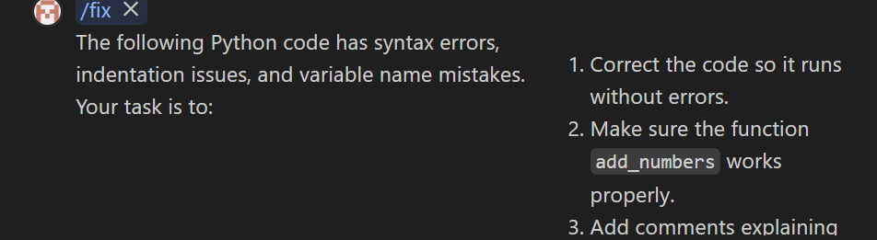

Code :-

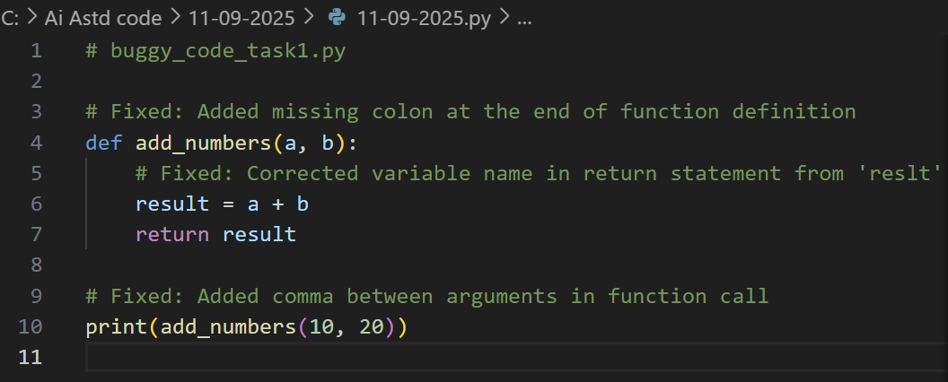

Output :-



**Task 2: Logical and Performance Issue Review**

**Task**: Optimize inefficient logic while keeping the result correct.

# buggy_code_task2.py

def find_duplicates(nums):

duplicates = []

for i in range(len(nums)):

for j in range(len(nums)):

if i != j and nums[i] == nums[j] and nums[i] not in duplicates:

duplicates.append(nums[i])

return duplicates

numbers = [1,2,3,2,4,5,1,6,1,2]

print(find_duplicates(numbers))

**Expected Output**:

* More efficient duplicate detection (e.g., using sets).
* AI should explain the optimization.

Prompt :-

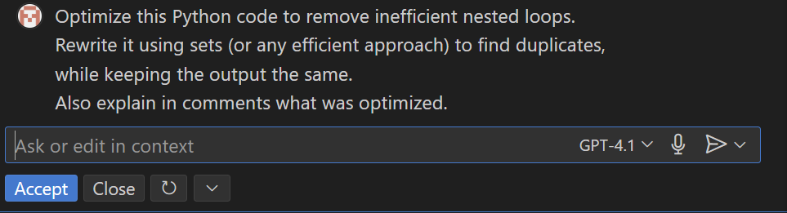

Code : -

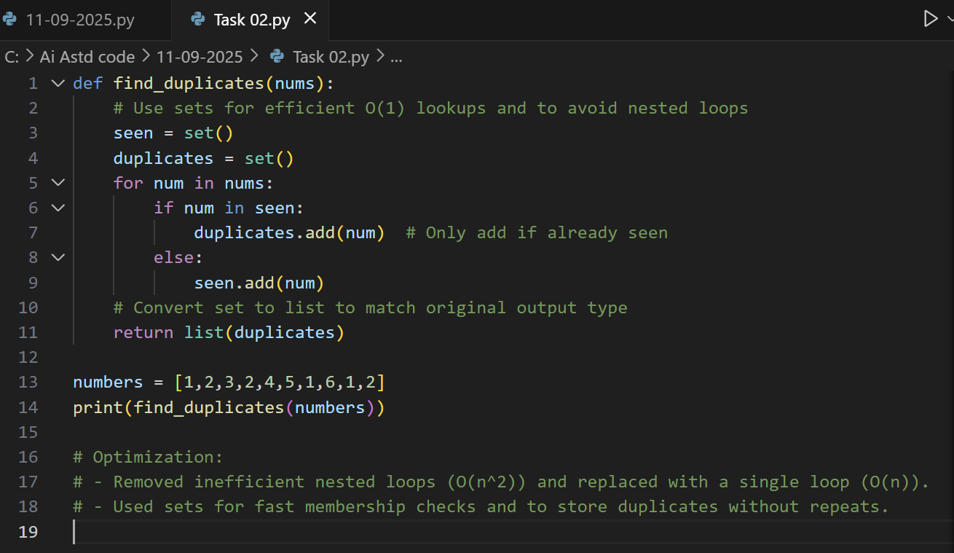

Output :-



**Task 3: Code Refactoring for Readability**

**Task**: Refactor messy code into clean, PEP 8–compliant, well-structured code.

# buggy_code_task3.py

def c(n):

x=1

for i in range(1,n+1):

x=x*i

return x

print(c(5))

Expected Output:

Function renamed to calculate_factorial.

Proper indentation, variable naming, docstrings, and formatting.

AI should provide a more readable version.

Prompt :-

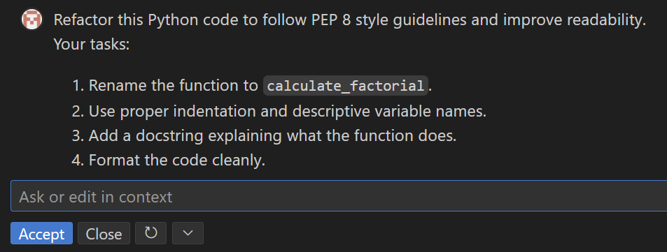

Code :- 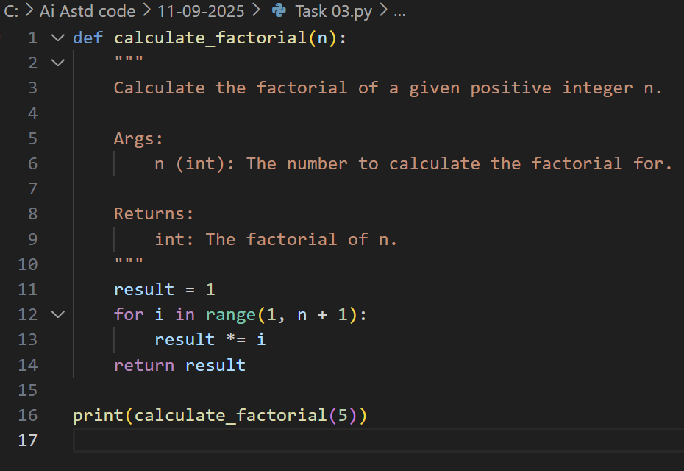

Output:-



**Task 4: Security and Error Handling Enhancement**

**Task:** Add security practices and exception handling to the code.

# buggy_code_task4.py

import sqlite3

def get_user_data(user_id):

conn = sqlite3.connect("users.db")

cursor = conn.cursor()

query = f"SELECT * FROM users WHERE id = {user_id};" # Potential SQL injection risk

cursor.execute(query)

result = cursor.fetchall()

conn.close()

return result

user_input = input("Enter user ID: ")

print(get_user_data(user_input))

**Expected Output:**

Safe query using parameterized SQL (? placeholders).

Try-except block for database errors.

Input validation before query execution.

Prompt : -

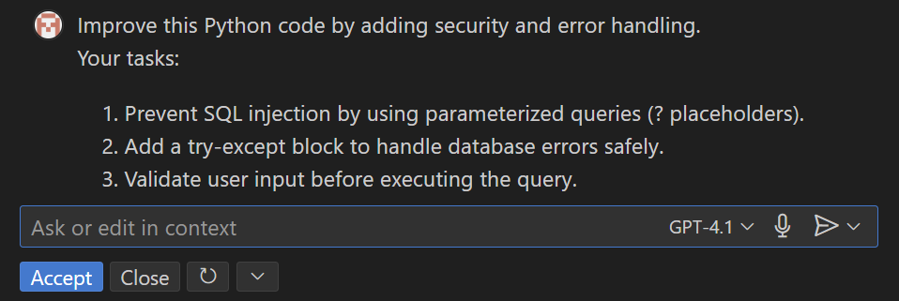

Code : -

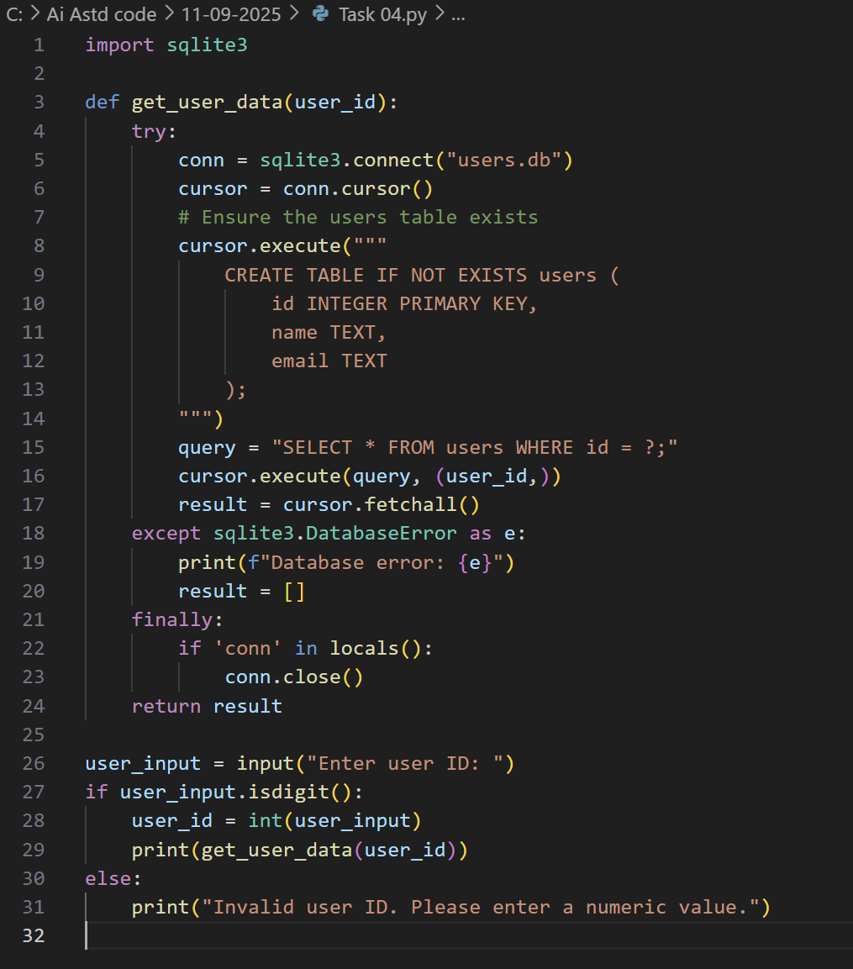

Output : -

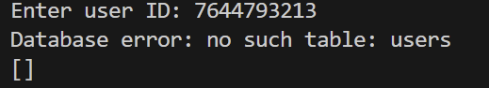

**Task 5:**

**Prompt :-**

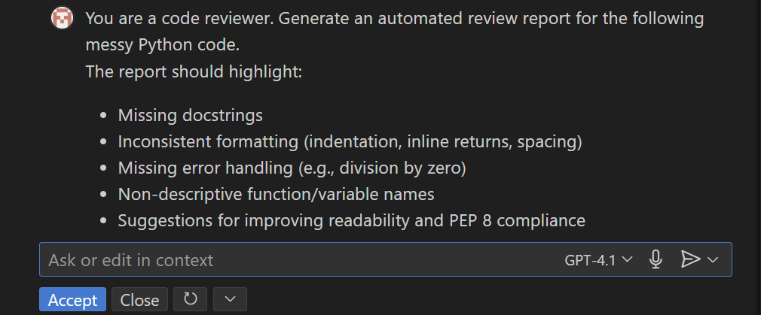

Code :-

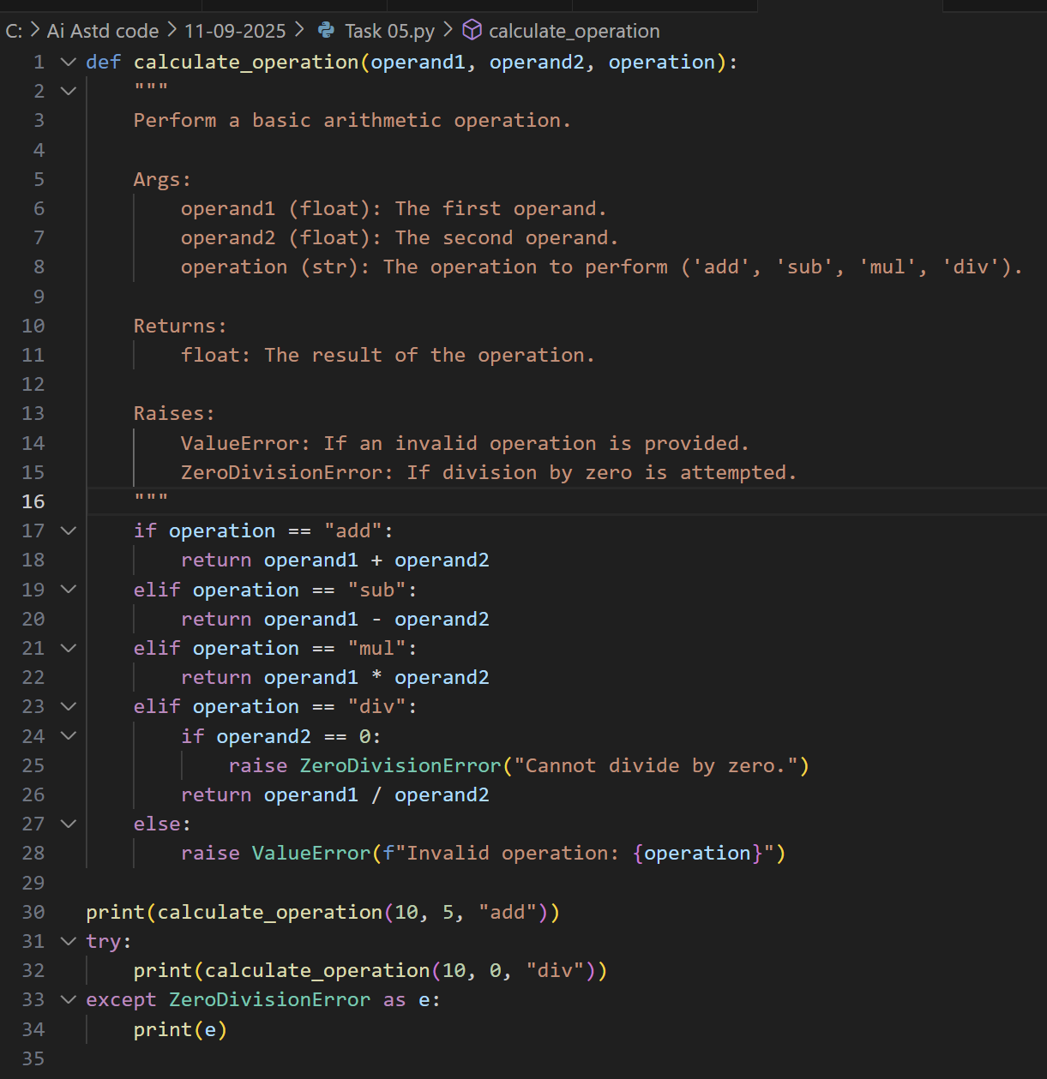

Output :-

